Digital Signal Processing
Year : 2016-17 Div : B.E. A,B,C
Lecture – 22

- Write Equation for DFT.
- Compare DFT and DTFT.
- Explain relation between DFT and DTFT.
Q1.)Given a sequence of N samples f(n), indexed by n = 0..N-1, the Discrete Fourier Transform (DFT) is defined as F(k), where k=0..N-1:
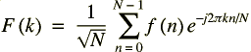

F(k) are often called the 'Fourier Coefficients' or 'Harmonics'.

Q2.) 1. Discrete Time Fourier Transform

The DTFT(Discrete Time Fourier Transform) is nothing but a fancy name for the Fourier transform of a discrete sequence. It is defined as:

The frequency variable is continuous, but since the signal itself is defined at discrete instants, the resulting Fourier transform is also defined at discrete instants of time. The number of time points will still be infinite.Its just that between any two time points you would have a finite number of points.
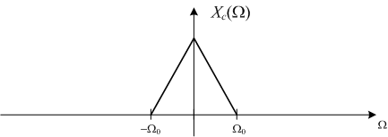
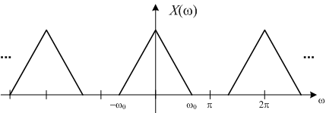

We also know that the Fourier transform of a sampled signal is a series of replications of the spectrum of the original signal at frequencies spaced by the sampling frequency.

Mathematically, this is expressed by

Here T is the sampling period.
So this is an alternate mathematical expression for the DTFT.

As we can see, the DTFT is periodic, with period equal to the sampling frequency. Hence we normally represent DTFT over a single period as shown below. This is implicit in the definition.
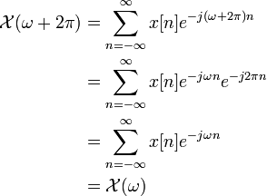

Mathematically this periodicity can also be seen by noting the periodicity of the discrete(in time) exponential

2.Discrete Fourier Transform

But the DTFT is difficult to evaluate on a computer, since a computer works only on finite number of points. So to make the evaluation of the DTFT possible on a computer, we choose a finite number of frequency points. This is equivalent to sampling the Fourier transform at a certain number of points.This is called the Discrete Fourier Transform(DFT).

The general convention is to use N frequencies separated by 2*pi/N radians. 2*pi corresponds to the angular frequency variation over one cycle of the original waveform(the cycle over which we take the N time samples) . We divide this into N frequency 'bins' which we index by an index variable k.
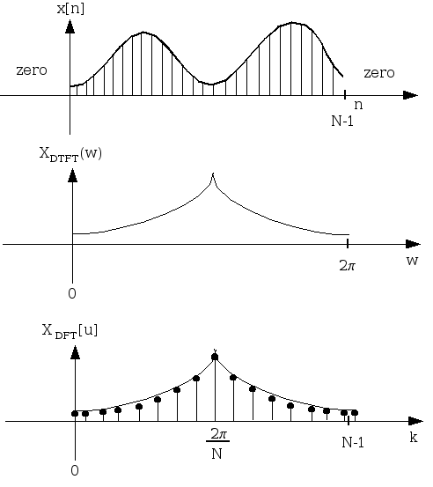

Mathematically, this is expressed as

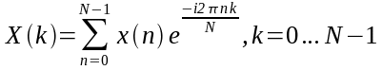
Since the DFT is basically the sampled version of the DTFT, it is also periodic, with period N(the number of frequency samples taken). Hence the DFT is also represented over one 'period'(discrete frequency period - N). This is implicit in the definition.

Mathematically, this periodicity can be see by noting the periodicity of the discrete(both in time and frequency) exponential

Q3.)
DTFT and DFT
To relate the DFT and DTFT, we will need to truncate the DTFT to a finite range of N samples.
In doing so, one would like to insure that the power of the signal in the excluded (truncated)
portion is insignificant, e.g. one would not want to approximate the DSFT with the DFT for
x(n) = sin(4πn), which will have significant power in any truncated portion. This is equivalent
to saying that the DTFT of x cannot have any delta functions.
Next, one needs to determine if the range of x(n) should be [0…N-1] or [-N/2…N/2-1]. That will
determine if ifftshift needs to be used. Now suppose we have a function that is zero for all
negative n and we determine a length N over which we’d like to examine. We can now
approximate X (ω) as ) X (k d , where k
Note that the continuous ) X (ω is now discretized or sampled. Locations of samples are either
ω depending of whether fftshift has been used.
This range is approximately [0..2π] or [-π…π], respectively. This introduces a second criterion
on selection N. If X (ω) appears to be sampled too coarsely, then N should be increased, even if
it means adding zeros to ends of the definition of x (know as zero padding).
BME 311/499.098 (Noll) DFT, DTFT, and DTF Notes
The inverse is relationship is also tricky. First, let’s assume that we have defined a continuous
X (ω) . Obviously, ) X (ω cannot have any delta functions as these cannot be represented on the
computer. This can be sampled at locations [0... 1] 2
one them implements the inverse DFT (ifft) to get a signal x(n). The tricky part arises from
the observation that the DFT is DFS are closely related. This means that by sampling X (ω) , we
have created a periodic x(n). This creates an ambiguity as to whether x(n) is defined for n in
[0…N-1] or [-N/2…N/2-1]. If we know (e.g. based on causality or whatever) that the output will
be zero for negative n, then we can use the output of the DFT for n in [0…N-1]. If we don’t
know, it might be wise to use fftshift and define n for [-N/2…N/2-1]. N should be chosen so
that x(n) had decayed to near zero at -N/2 and N/2-1.

